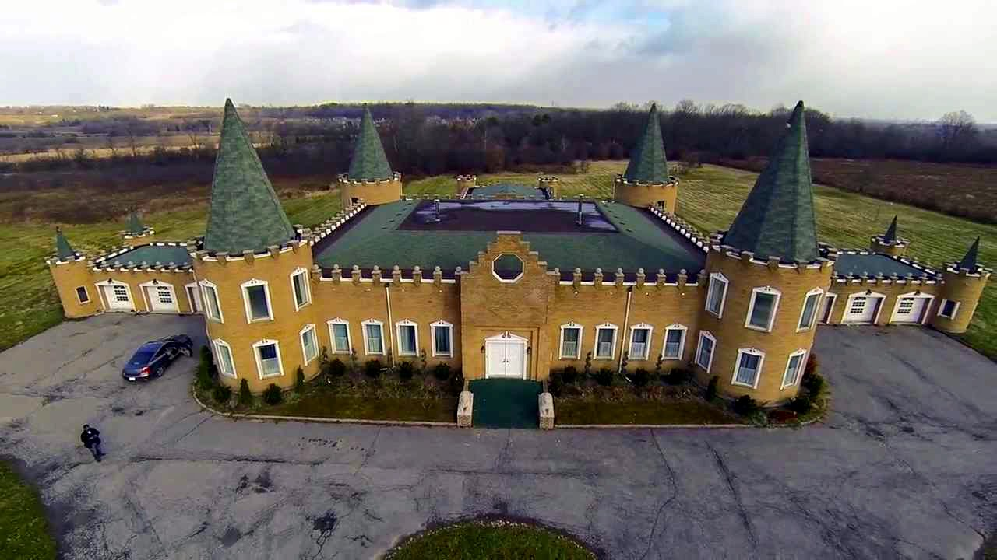

[Durham Mosque Baitul Mahdi](https://www.google.com/url?sa=i&url=https%3A%2F%2Fwww.facebook.com%2Fdurhammosque%2F&psig=AOvVaw2UtB6urq_gz5Hww4VJpf9P&ust=1622754087305000&source=images&cd=vfe&ved=2ahUKEwj1xtyY7PnwAhUfA50JHepGBZsQr4kDegUIARCkAQ) [**Address**](https://www.google.com/search?hl=en-GB&sxsrf=ALeKk01VqHjbbvadhfWvx5mHTqUCsL-mkg:1622667736599&q=baitul+mahdi,+durham,+on+address&stick=H4sIAAAAAAAAAOPgE-LVT9c3NEw3yMmoTCvI0JLNTrbSz8lPTizJzM-DM6wSU1KKUouLF7EqJCVmlpTmKOQmZqRk6iiklBZlJObqKOTnKUCVAACLT1TPUwAAAA&ludocid=11025700187287622888&sa=X&ved=2ahUKEwjkjYWw7PnwAhXNVs0KHXzJCA8Q6BMwBXoECBQQBw)**:**3505 Salem Rd, Locust Hill, ON L0H 1J0